TIY Trauma-informed Yoga

hosted by MIND Aberystwyth.

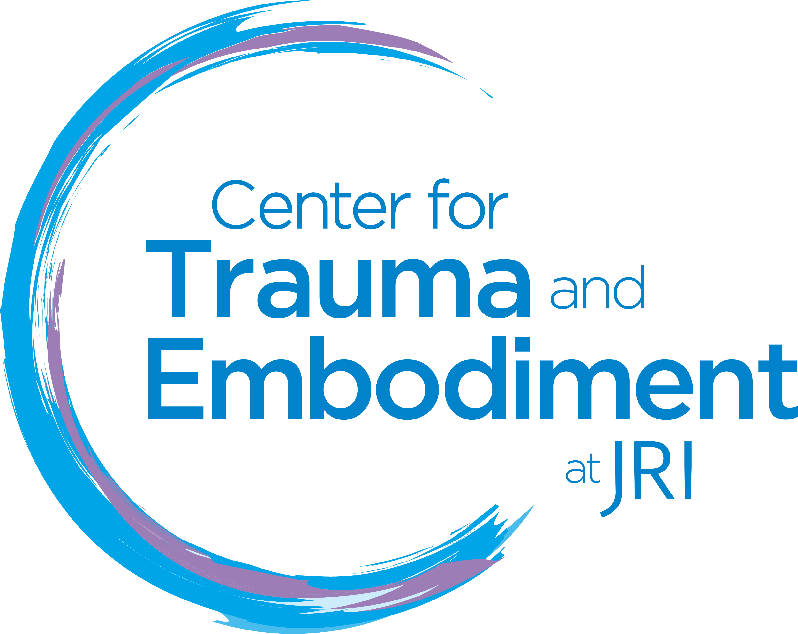 |  | 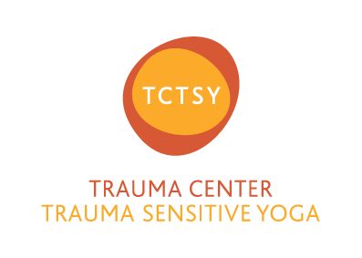

Trauma-informed Yoga (TIY) is an online service hosted by Mind Aberystwyth. Please complete and return to info@mindaberystwyth.org.

In order to make these sessions as meaningful and effective as possible we need to gather some information about you as well as asking you to prepare for the session in advance by reading through what we need from you and then sign the attached pro-forma to acknowledge that you have done so.

This will also act as confirmation of your consent to Mind Aberystwyth retaining the details you have provided in line with our privacy policy.

Should you need any additional support in completing the form, or answering any of the questions, please contact Mind Aberystwyth 01970 626225.

TIY Trauma-informed Yoga

Participant information

Your full name:

Online/screen name (if different):

Email address:

Postcode:

The name of someone you would like us to contact in an emergency name/number? | Name
 | Tel Number
Is there anything about your movement you'd like Meriel to know about?
e.g. It's helpful to know if you can or cannot lie-down/sit/stand etc.

Do you have any injuries or medical conditions you'd like Meriel to know about?

Is there anything else you feel is important to share with Meriel ahead of the session?

Feel free to change and revise the above at any time in the future by contacting
Mind Aberystwyth or making Meriel aware during a session.
Please read the following basic guidance before each session.
- Clear some space in your room/home so you can join in the session safely.

- Let any people you live with know that you are doing a Yoga session and ask for privacy if that's helpful for you.

- Have some water to hand

- Feel free to stop whenever you choose to.

- You are welcome to speak to Meriel during the session, e.g. ask her to repeat something or let her know something. You can also use the chat box privately or with the group to do this.
- Think about someone you can reach out to or speak to after or during your Yoga session, if needed
- Finally, you can contact Meriel after each session on info@yogaintherapy.com Meriel aims to reply within a week.

Please read and indicate tick the Y/N to indicate your understanding | Yes | No
- My doctor has said it is ok for me to do gentle exercise like Yoga.

- I understand that Meriel and Mind Aberystwyth will do all they can to make the on-line platform as safe and private as they can make it but due to the nature of on-line services absolute privacy cannot be guaranteed.

- I understand that under no circumstances do I have permission to record any part of the TIY sessions.

- I acknowledge that neither Meriel Goss nor Mind Aberystwyth can take responsibility for me during online sessions under any circumstances.

- I therefore undertake full responsibility for myself whilst partaking in TIY online Yoga sessions.

- I agree to Mind Aberystwyth storing the information contained in this form. It will only be used in accordance with our privacy policy to ensure the safe operation of this service.

Please sign and date the form
Signature …………………………………………………. Date……………………….

Copy available on our website www.mindaberystwyth.org

