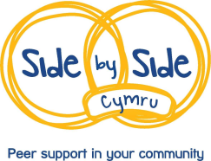
Side By Side Cymru Membership Form
Mind Aberystwyth is delivering the Side By Side Cymru Project which aims to improve the quality of Peer Support available in the community.
The project will be a central point of contact for Peer Support in Ceredigion, Pembrokeshire and Carmarthenshire.
If you would like to receive information about our training and events please complete this form and return to Mind Aberystwyth, The Cambria, Marine Terrace, Aberystwyth, SY23 2AZ.
Name of group:

Who does the group engage with? What type of peer support are you involved in?

How many people are you engaged with?
Named contact for group:

Telephone number:

Home address:

Email address:

How would you prefer to be contacted?

Please circle: Telephone Email Post

Please tell us what sort of training you are interested in?

Tick if interested
Setting up a peer support group.

Running a peer support group: Practical Activities

Recovery and Group Dynamics.

Active listening skills
Dealing with challenges

Funding

Understanding your impact

Is there any other training that would be helpful to people who are involved in peer support groups? Please specify:

Can Mind’s Project Worker visit your group to share information about this project?

How we process the information you provide:
We take your privacy seriously and promise to never sell your data. We will use the information you have provided to provide you with the services you have requested.
You can find out more about your rights, how we use your personal information and how we keep your details safe and secure by reading our Privacy Policy. For more information on our Privacy Policy or to withdraw your consent to us processing your data, please contact Mind Aberystwyth on 01970 626225 or at info@mindaberystwyth.org

