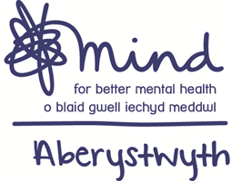
ACTIVITY REFERRAL FORM

Activity (please circle): Art group / Creative Hub / Recovery and Beyond
My Generation / Woodland Group

Date: | Person making referral:

Name:
Address:
Telephone number:
Date of birth:
Emergency contact:
Any medical conditions or medication that we need to be aware of? | Please give details:
Any accessibility conditions that we need to be aware of? | Please give details:
Are you supported by any other agencies? | Please give details:

RISK ASSESSMENT
Please provide details if any of the following risks are applicable:
Any history of aggression or violence?

Any current use of alcohol or substances?

Any history of or current risk of self harm or suicide?

Vulnerable to exploitation from others?

Any history of or current risk of domestic abuse?

Any other risks that we should be aware of?

Data Sharing Authorisation
I understand that the information on this form will be kept confidential by Mind Aberystwyth in accordance with data protection,. However, if Mind Aberystwyth, believe that there is significant risk of harm to myself or another person, they may need to divulge or seek further information from other agencies.

Signed:

